**EIA2 Endabgabe WS22/23**

**Konzept**

**Nicolai Pfrengle - 266982**

**Use Case Diagram**

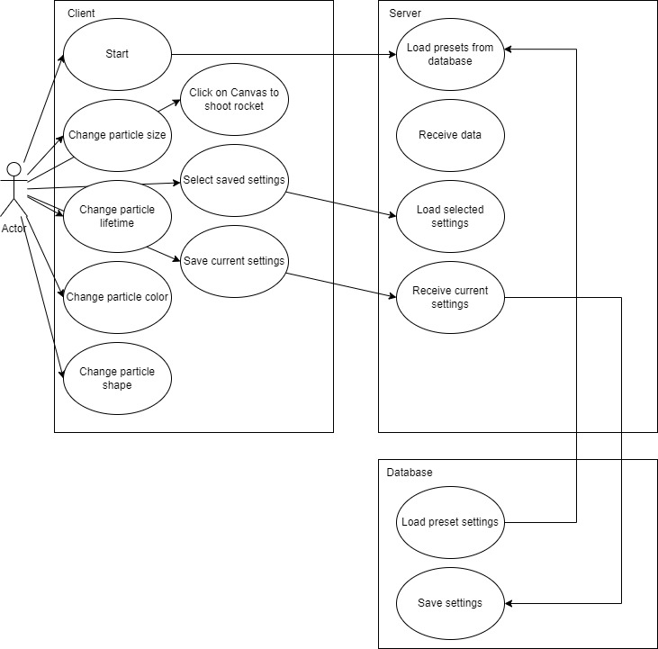

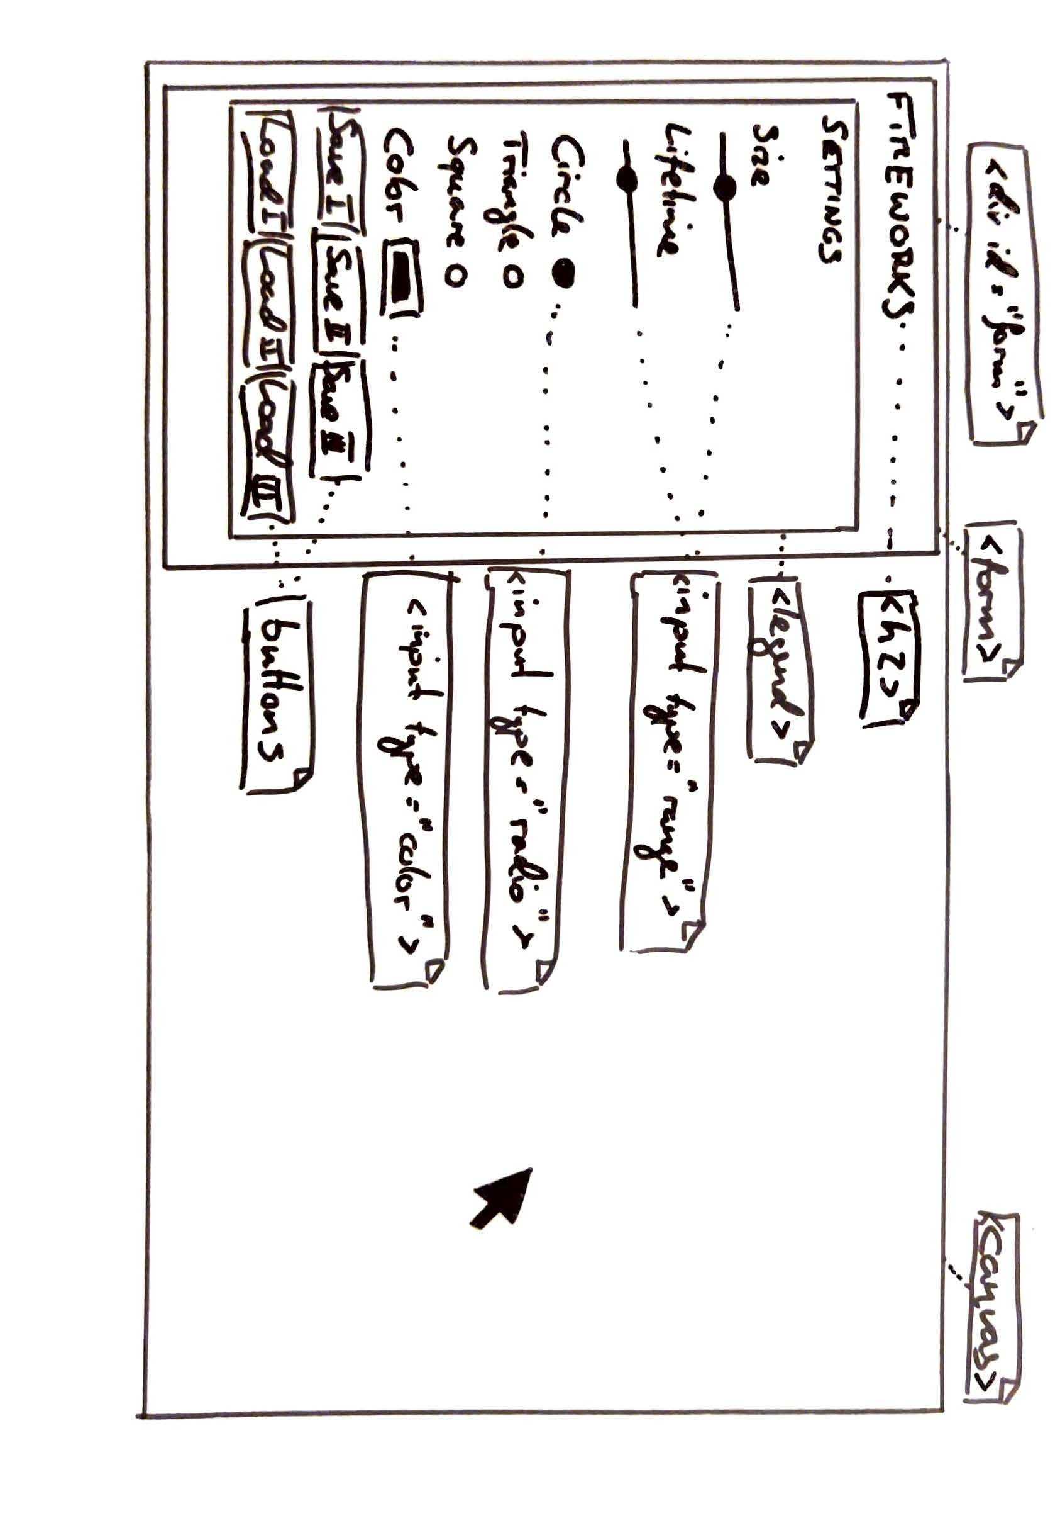**UI Scribble**

**Class Diagram**

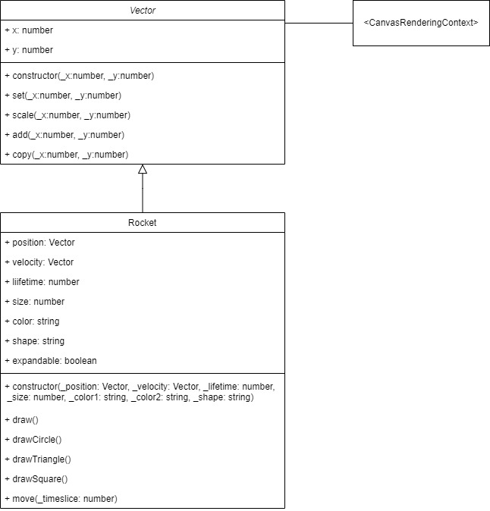

**Activity Diagram Main**

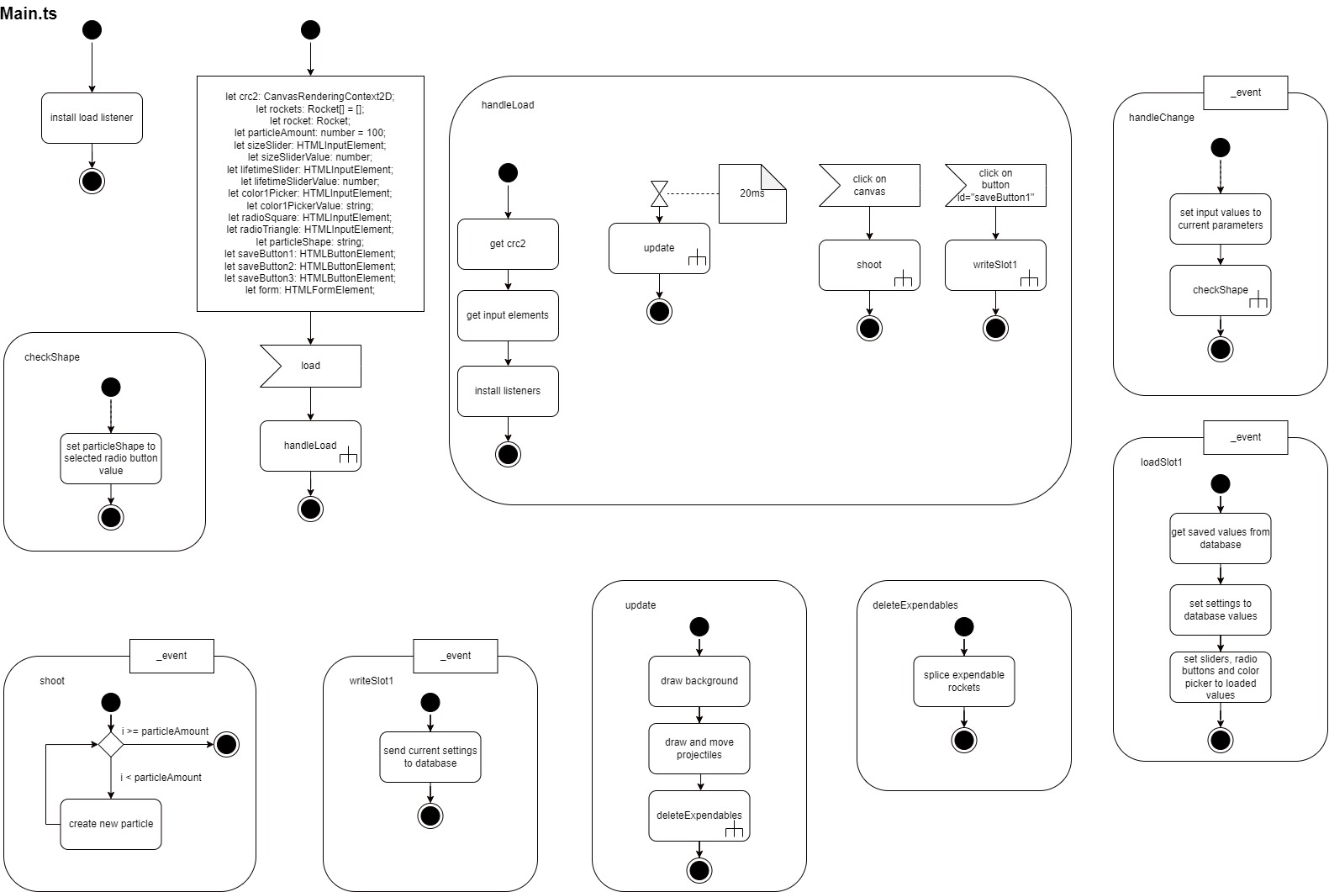

**Activity Diagram Vector**

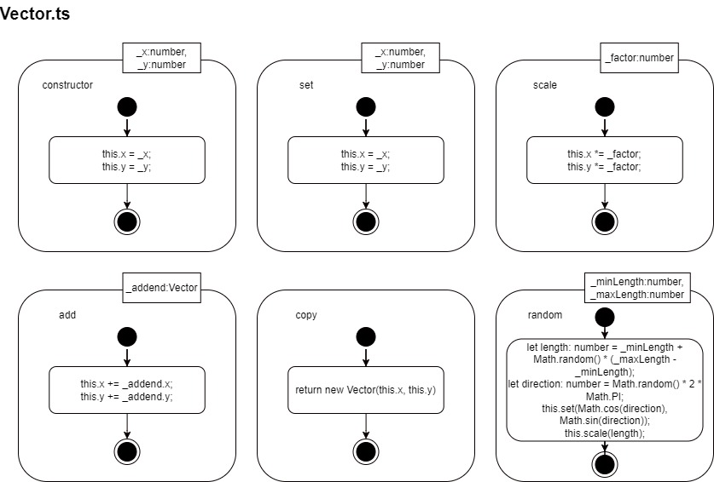

**Activity Diagram**

